APPENDIX A: AE REQUALIFICATION HCSIS TIP SHEET

This tip sheet provides guidance for Administrative Entities (AEs) on how to review, update, and document provider qualification determinations in HCSIS during the requalification process. It explains common screen displays, what they mean, and the required AE actions for each scenario.
Scenario: New Provider Qualification Screen for AEs is Blank

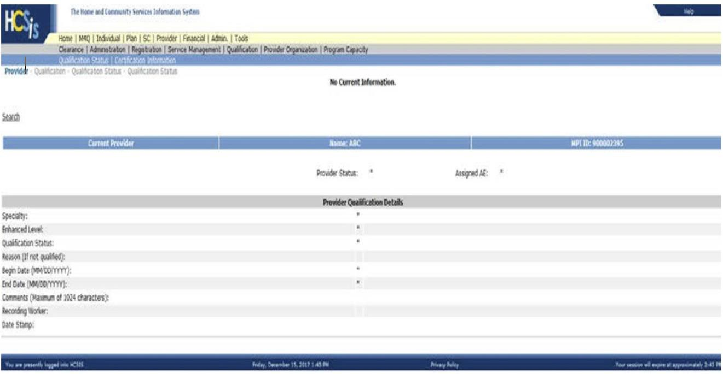

When the provider qualification status screen is blank, this indicates that the provider’s PROMISe® enrollment application is still in process or not yet completed. As a result, the provider does not appear in HCSIS for any ODP programs, and no specialties are available to update.

Only ODP Enrollment Staff can add new specialties to a provider’s qualification screen once their PROMISe® enrollment becomes active.
Scenario: Requalifying a provider when Provider Status shows “New”

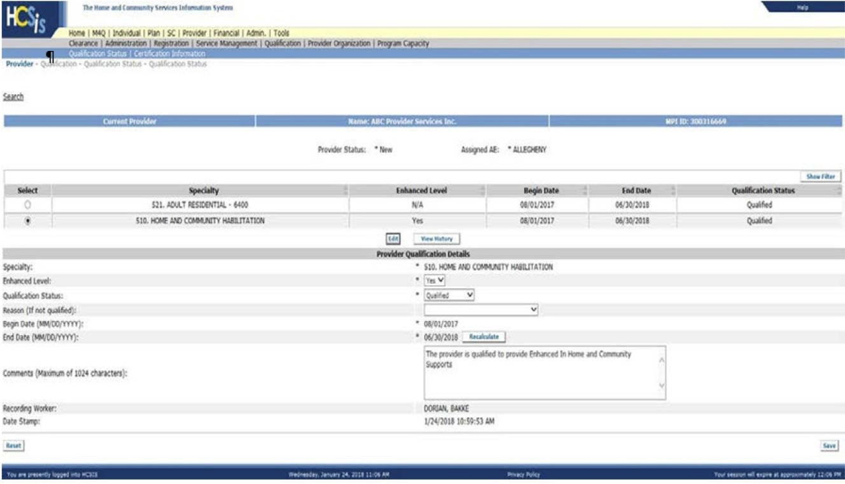

A provider assigned the status of “New” has not previously been enrolled in any ODP waiver program. If the provider is due for requalification while still in “New” status, the AE must update the qualification status and recalculate the qualification end date.
To complete this process, the AE must:
• Select the radio button for the applicable specialty.
• Click the Edit button.
• Update the Qualification Status field to either Qualified or Not Requalified.
• If selecting Not Requalified, choose the appropriate reason from the drop‑down menu.
• Select the Recalculate button to generate the correct cycle end date.
• Enter comments describing supporting documentation or decisions.
• Click Save.
On July 1, if the provider has been requalified, the system automatically updates the provider status from “New” to “Existing.”
Enhanced Level Requirements
If an enhanced level exists for the specialty, the AE must select either Yes or No. The enhanced level field cannot be left blank or the system will not save the updates. AEs should also document what enhanced-level criteria or documentation were reviewed.
If an AE receives an error when selecting Recalculate, they should contact their Regional Program Office.

Scenario: Updating Qualification Status for an Existing Provider
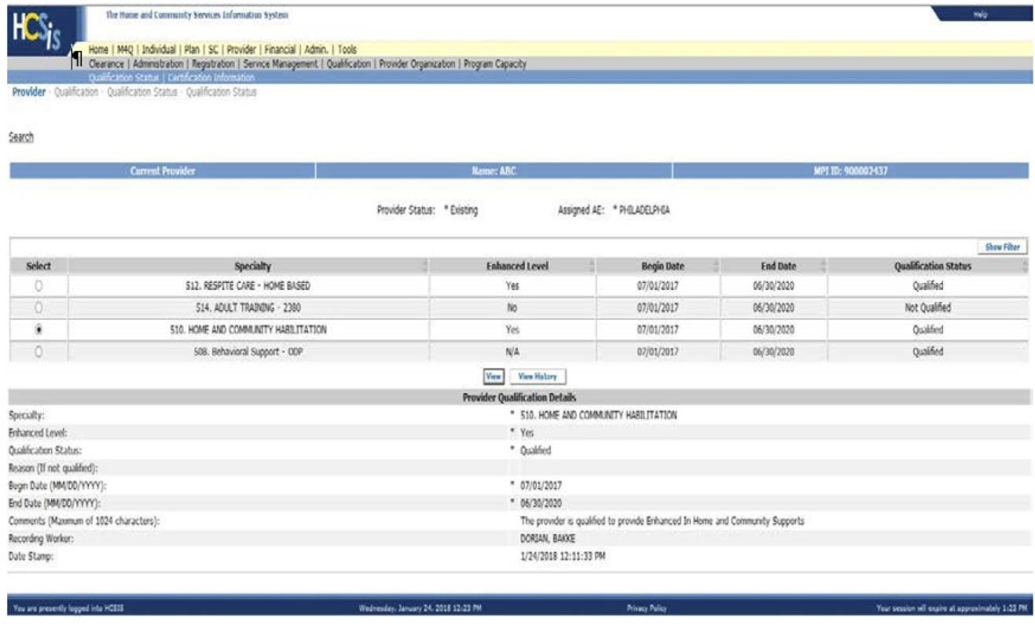

When the provider status is “Existing,” the AE follows the same requalification steps described above. The system will automatically calculate the new qualification end date based on the cycle.
To modify an end date outside the standard calculations such as when a provider is being terminated, the AE must contact their Regional Program Office.

Common AE Errors to Avoid
• Failing to select Yes or No for Enhanced Level, resulting in unsaved changes.
• Updating fields but not clicking Save.
• Not selecting Recalculate after updating the qualification status.
• Attempting to enter requalification results before PROMISe® enrollment is active.

