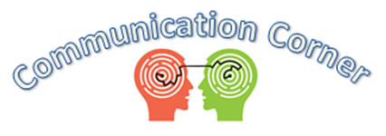

March is Developmental Disabilities Awareness Month!
To celebrate this important month, we wanted to share tips for encouraging inclusive communication environments. Our access to communication is the backbone of our connection to one another. By ensuring that all people have the opportunity to engage in communication in any environment, we promote equality, understanding, and engagement.
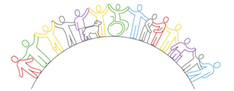
- Be aware of space, lighting, and the position of objects within the room. Ensure there is room for a person’s adaptive technology, lighting appropriate to the person’s visual needs, and ample space to move around or engage interpreters, etc.

- Think about noise and crowds. Is the space noisy? Would it be hard to hear if you use a hearing aid or distracting if you use an interpreter? Is it overwhelming to someone’s sensory needs?

- Allow for multimodal communication. Does everyone in the environment promote communication in different ways? Is there access to sign language? Is there a communication board? Can someone charge their communication device?

- Know what to expect. Do people know what to expect in the environment? Is it familiar? Do they know the people around them? Is the routine posted clearly in a communication mode people understand?

- Re-evaluate frequently. Communication needs change over time. It is important to continually assess the environment for barriers and adapt as needed.

