Personal Strengths & Assets  Learn about and try different transportation options  Wear a mask when needed  Ride an electric bicycle  Engage in the community  Be willing to meet responsibilities in using transportation  Recognize and develop skills for using transportation  Know where to find assistance and ask for help  Plan your trip ahead of time. Know where you need to be and what time to be there.  Obtain a driver’s license and car  Learn to use Google Maps/other maps  Learn safety features within transportation apps | Technology  Public Transportation Services and Programs Map  Find My Ride (FMR) – This allows people in most PA counties to apply for transportation assistance programs  Aunt Bertha: Search and Connect for Help  Tips and Guidelines for Using Mass Transit for Individuals with Autism – These tips and guidelines are helpful for all people  Use a search engine on your computer to research local transportation options in your city or town (like busses, trains, taxis, and bicycle rentals)  Vehicle modifications  Uber and Lyft Apps, with attention of safety features  Tech Owl | Relationships  Family and friends  Coworkers and neighbors  Helpful professionals to assist in connecting to transportation  Information and Referral (I&R) Resources  You may also dial 2-1-1 to reach your local United Way helpline  Employer-offered transportation programs like vanpooling  Professionals, friends, or family can help coordinate/rent vans for trips  Go-Go Grandparent  PA Centers for Independent Living (CIL’s)  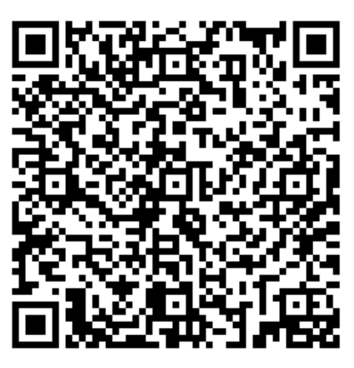 | Community Based  Ridesharing Programs. including car and vanpool options  PennDOT-Maintained Park and Ride Facilities  Private Pay and Publicly Funded Programs - Some can help with finding accessible transportation, a ride to the store or a medical appointment  AMTRAK  Greyhound Bus Lines  Mobility Works  Megabus  University Transportation Centers (UTCs)  PA Developmental Disabilities Council Grants  Care Driver | Eligibility Specific  Office of Vocational Rehabilitation (OVR)  Schools and Intermediate Units (IU’s)  Home and Community Based Services - PA Link to Community Care  Medical Assistance Transportation Program (MATP)  Older-Adult Auto Insurance Discounts  Retired-Status Registration  Low-Vision Licenses  Programs for Seniors and People with Disabilities  Parking Placard and/or Registration Plate  Community Health Choices (CHC)

