- Ensure that you are utilizing all current resources that were sent via the QA&I Mailbox and posted on the MyODP Training & Resource Center under the For AEs section.
- The AE Tracker should be submitted to the appropriate QA&I Regional Coordinator (RC) the first Monday of every month from September to January.
- Pull and analyze, per the QA&I Provider Prep document, the Provider Financial Metrics Report (current and prior FY) and Provider Service Detail Report (current and prior FY) prior to each Provider full review conference.
  - Consider any changes within the Provider organization that have occurred over the past two (2) years. Changes would include but are not limited to: change in leadership, number of individuals served, utilization changes, and/or decline or growth.
- Notes should be taken during the conference meeting and used in the development of the Provider’s Comprehensive Report.
- There are two separate individual record samples for Providers that render both traditional and Agency with Choice Financial Management Services (AWC FMS) services. AEs are to select the individuals for review of the traditional services, ODP will provide the individuals selected for the review of AWC FMS services.
  - If an individual is included in the sample for the review of AWC FMS services, the individual cannot be included in the sample for the review of traditional services.
- If a Provider renders both traditional and AWC FMS services, the AE will be responsible for reviewing and answering the data and policy questions for both services. For the individual record reviews, you will also be responsible for reviewing and answering the AWC Provider Record Review and AWC Managing Employer Interview questions for all individuals in the AWC sample.
- Pay attention to the guidance as there are instances where comments or additional information is needed as part of the response to a question.
  - As a reminder, comments are mandatory for all instances when a “No” response is selected.
- The training tracker has been embedded into the QA&I Review Spreadsheet. Please follow the instructions on the “How To Use Spreadsheet” tab when completing these questions as the information entered in the applicable tab will populate the “Questions” tab.
- Please ensure that you are reviewing the remediation guidance for each question before remediation is accepted, validated, and approved.
- The “QA&I Cycle 2, Year 2 Provider Full Review Spreadsheet” should be used for all remediation activities. Once completed, this spreadsheet should be included as an appendix to the Comprehensive Report.
- The Corrective Action Plan (CAP) template should be used for systemic improvement activities.
- The final Comprehensive Report must be sent to the Provider as a PDF document.
- When sending the final Comprehensive Report and all appendices to the Provider, remember to include the appropriate QA&I RC.
All resources can be found on MyODP at Quality Assessment & Improvement Resources

QuestionPro Specific Information:
- Please pay attention to the questions being asked in QuestionPro. There is logic built into the tools to skip questions based on the response to previous questions.
- There is a separate Data and Policy Tool for all data and policy questions and a separate Record Review Tool for all record review questions.
  - For each entity receiving a full review, you must do the following:
    - Data enter responses for all the data and policy questions in the Data and Policy Tool for each Provider assigned to your AE.
    - Data enter the individual record review responses for all the record review questions in the Record Review Tool for each individual selected as part of the Provider’s full review.
      - If a Provider does not serve any individuals, you will not utilize this link for that specific Provider.
      - As a reminder, for record review questions, you are only answering the questions based on the services received from the Provider being reviewed for the QA&I full review.
    - For individuals that receive AWC FMS services, you will answer the AWC Record Review and Managing Employer interviews questions only.
  - Only one remediation action should be selected.
    - Comments are required when “other remediation action” and “remediation by exception” is selected.
Provider Full Review Data and Policy Tool
- If a Provider renders both traditional and Agency with Choice (AWC) Financial Management Services (FMS) services, you will be responsible for reviewing and answering all questions in the Provider Tool for both services.
  - In QuestionPro, in the Demographics section you will be asked to indicate the ODP Waivers and/or Programs for the Provider.
    - Selecting the Agency with Choice Financial Management Services (AWC FMS) box indicates that the Provider is a traditional Provider and an AWC FMS Provider.

    - After all the data and policy questions are answered and the question related to the Provider having an individual record review sample is answered, the following question is asked: “The Provider is an Agency with Choice (AWC) Financial Management Services (FMS) Provider scheduled for a full review.”
      - A “Yes” response to this question will display all the AWC FMS data and policy questions.
      - A “No” response to this question will skip all the AWC FMS Data and Policy questions and will go to the Comments section to capture any additional comments.
    - Please note: Selecting “Agency with Choice Financial Management Services” in the Demographics section, does not necessarily mean that there should be a “Yes” response to the question below. A Provider could be an AWC FMS Provider; however, they may not be scheduled for a full review in Cycle 2, Year 2 (C2Y2).
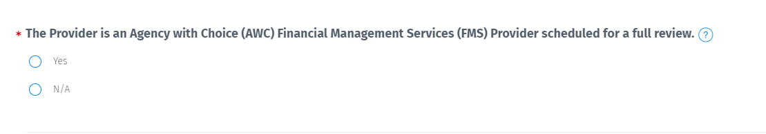
Provider Individual Record Review Tool
- In QuestionPro, you will see the following question: “The individual has been selected as part of the AWC FMS sample provided by ODP.”
  - A response of “Yes” will prompt the AWC FMS record review questions and Managing Employer Interview questions to show on the Record Review Tool. All traditional record review questions will be skipped.
    - Please note that a “Yes” response to this question should only be selected if the individual is a part of the AWC FMS Sample provided by ODP. If the individual is included in the AWC FMS Sample, the individual cannot be included in the sample for the review of traditional services
- All data entry for full reviews (data and policy, record reviews and ME interviews (as applicable)) must be completed and submitted by 3/31/24.
- All QA&I Comprehensive Reports must be issued and finalized by 3/31/24.
Below is the list of the subject line for the separate emails that contain the unique QuestionPro hyperlink associated with the AE QA&I Provider Lead Primary Contact’s email address.
Activity | Email Subject Line
Provider QA&I Full Review – Data and Policy | Action Required! The QA&I Cycle 2, Year 2 Questions Tool for Providers – Data and Policy is now available!
Provider QA&I Full Review – Record Review | Action Required! The QA&I Cycle 2, Year 2 Questions Tool for Providers – Record Review is now available!

