Employment First Report
Pennsylvania Office of Developmental Programs
Issued February 14, 2023
Contents
Introduction 3
A message for stakeholders 3
Background 3
What is competitive integrated employment? 4
Sources of Data 4
SECTION 1: Competitive Integrated Employment 6
COVID-19 Pandemic and Recovery 7
Focus on Transition-Aged Youth 9
Pennsylvania Secondary Transition Connecting for Employment 9
SECTION 2: Employment Services 11
Benefits Counseling 13
SECTION 3: Employment Goals 15
SECTION 4: Types of Jobs 17
Collaboration with Workforce Development Professionals 18
Section 5: Racial Equity 19
Section 6: Prevocational Services 21
Subminimum Wage Employment for Workers with Disabilities 21
Section 511 of the Rehabilitation Act of 1973 Amended by the Workforce Innovation and Opportunity Act of 2014 21
Supporting Provider Transformation 22
Moving Forward 23

Introduction
The Office of Developmental Programs believes that all people with an intellectual disability and/or autism must be encouraged to pursue their vision for an everyday life, which may include working in competitive integrated employment. Competitive integrated employment offers a person an opportunity to achieve economic independence, build self-confidence, enhance self-determination, and meet new people while building new skills. The Everyday Lives: Values in Action publication, developed by the Office of Developmental Programs’ Information Sharing and Advisory Committee which includes self-advocates, reads, “Employment is a centerpiece of adulthood and must be available for every person. The benefits of employment for people with disabilities are significant and are the same as for people without disabilities.”
This report serves as an update to all stakeholders on the progress that has been made to support individuals served by the Office of Developmental Programs on finding and maintaining competitive integrated employment.

A message for stakeholders
The Office of Developmental Programs wishes to acknowledge that improving quality of services and employment outcomes for individuals is not possible without the valuable feedback and partnership that the Office of Developmental Programs receives from individuals and their families, providers, Supports Coordination Organizations, County Intellectual Disability Programs/Administrative Entities, advocates, state agencies, and other stakeholders.
The Office of Developmental Programs also acknowledges that providers of all types are experiencing a workforce crisis and the dedication of the direct support professionals, employment specialists, management, and others within the organization to continue to serve individuals during this challenging time is exceptional.

Background
The Office of Developmental Programs’ employment policies and program designs are influenced by a number of factors including:
Number 1 The Workforce Innovation and Opportunity Act
Designed to help people with disabilities access employment, education, training, and support services to succeed in the labor market and match employers with the skilled workers they need to compete in the global economy.
Number 2 Everyday Lives: Values in Action
With the publication of the Everyday Lives: Values in Action document, the Office of Developmental Programs’ Information Sharing and Advisory Committee developed a detailed series of recommendations, strategies, and performance measures; including Recommendation #3 to increase employment.
Number 3 Pennsylvania Executive Order and Statute
The Pennsylvania Employment First Executive Order was signed by Governor Wolf in 2016 establishing an “Employment First” state, meaning that competitive integrated employment is the first consideration and preferred outcome of all publicly funded education, employment and training, and long-term supports and service programs for working-age Pennsylvanians with a disability. Act 36 of 2018, the Employment First Act, elevates the 2016 Executive Order for “Employment First” into Pennsylvania statute.

What is competitive integrated employment?
An individual with a disability is:
- Earning minimum wage or higher.
- Paid at least the same rate that is paid to people without disabilities that perform the same work with similar training, experience, and skills.
- Eligible for the same level of benefits provided to other employees.
- Employed in a setting where he or she interacts with other persons who are not individuals with a disability.
- Presented opportunities for advancement that are similar to those for other employees who are not individuals with disabilities and who have similar positions.
Competitive Integrated Employment can be full time or part time, and includes self-employment.

Sources of Data
Unless otherwise specified, data contained in this report is for working- age adults, ages 18 to 64, enrolled in the Consolidated, Community Living, Person/Family Directed Support, and Adult Autism Waivers as well as base funded services and Supports Coordination only.
The following sources were used for the data contained in this report:
Number 1: Individual Monitoring Employment Questions
Individuals receiving services are asked questions about employment during meetings with a Supports Coordinator. Meetings occur initially and throughout the year. Because monitoring is conducted at various timeframes depending on the program, responses to each monitoring question are carried through to the following month until a new monitoring is conducted.
Number 2: The Home and Community Services Information System
Number 3: The Department of Human Services’ claims processing and management system.
Number 4: The Commonwealth Workforce Development System
The Office of Developmental Programs and the Office of Vocational Rehabilitation have had a Memorandum of Understanding in place since 2017 that allows the Office of Developmental Programs to receive data from the Commonwealth Workforce Development System that assists in service coordination for people that are receiving services from the Office of Developmental Programs and the Office of Vocational Rehabilitation.

SECTION 1: Competitive Integrated Employment
Each time a Supports Coordinator conducts monitoring with a person, data is collected on the Individual Monitoring Tool in the Home and Community Services Information System. The data for each month includes all persons enrolled with the Office of Developmental Programs, not just those that had a monitoring visit with their Supports Coordinator that month. If a person did not have a monitoring visit with their Supports Coordinator, the response from their most recent monitoring visit is carried over to capture changes in employment status over time.
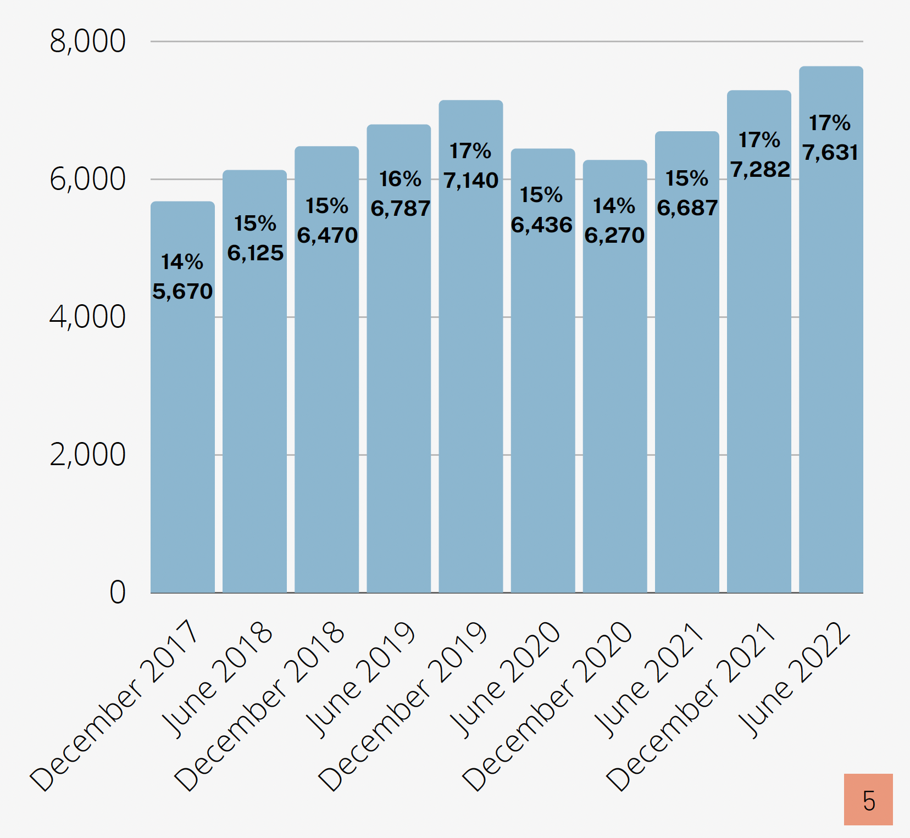
Data from the bar chart is as follows:
Month and Year | Number of People | Percent of People
December of 2017 | 5,670 | 14%
June of 2018 | 6,125 | 15%
December of 2018 | 6,470 | 15%
June of 2019 | 6,787 | 16%
December of 2019 | 7,140 | 17%
June of 2020 | 6,436 | 15%
December of 2020 | 6,270 | 14%
June of 2021 | 6,687 | 15%
December of 2021 | 7,282 | 17%
June of 2022 | 7,631 | 17%

COVID-19 Pandemic and Recovery
As a result of the COVID-19 pandemic, the national and state unemployment rate increased for both individuals with and without disabilities; with the increase for those with disabilities dramatically higher. From February of 2020 to July of 2020, 871 less people enrolled with the Office of Developmental Programs had competitive integrated employment. Since March of 2021, there has been a continuous, steady increase in the number of people that have competitive integrated employment. The number of people with competitive integrated employment in June of 2022, exceeds the number of people that had competitive integrated employment pre-pandemic.
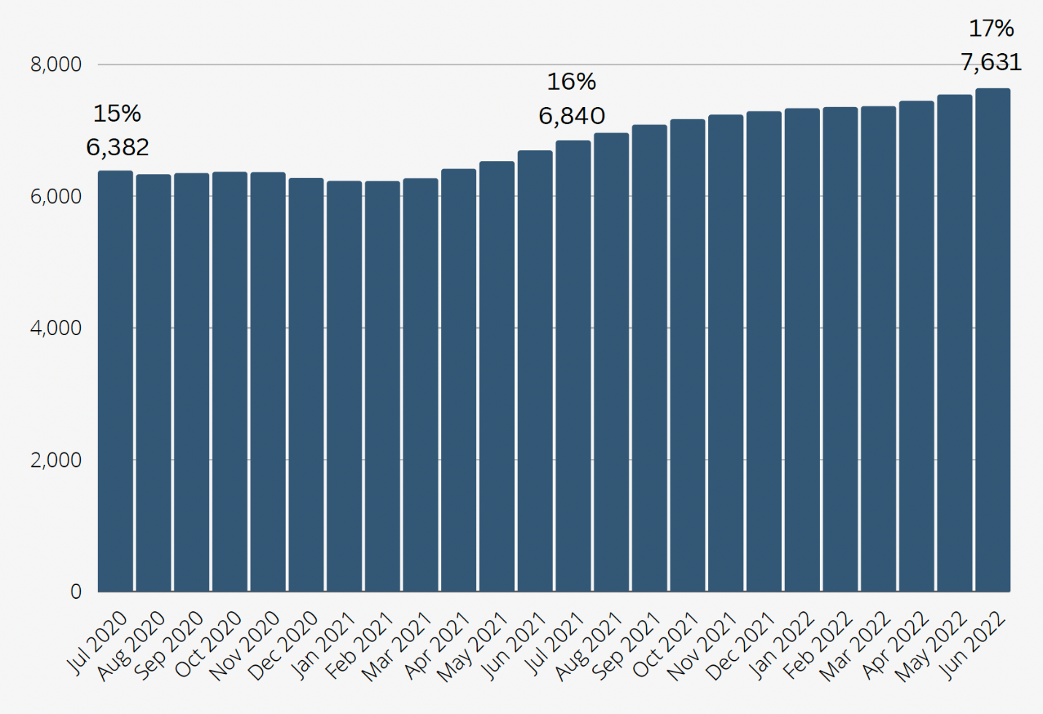
Data from the bar chart is as follows:
Month and Year | Number of People | Percent of People
July of 2020 | 6,382 | 15%
August of 2020 | 6,324 | 15%
September of 2020 | 6,344 | 15%
October of 2020 | 6,363 | 15%
November of 2020 | 6,358 | 15%
December of 2020 | 6,270 | 14%
January of 2021 | 6,224 | 14%
February of 2021 | 6,223 | 14%
March of 2021 | 6,265 | 14%
April of 2021 | 6,408 | 15%
May of 2021 | 6,525 | 15%
June of 2021 | 6,687 | 15%
July of 2021 | 6,840 | 16%
August of 2021 | 6,954 | 16%
September of 2021 | 7,078 | 16%
October of 2021 | 7,162 | 16%
November of 2021 | 7,229 | 17%
December of 2021 | 7,282 | 17%
January of 2022 | 7,327 | 17%
February of 2022 | 7,345 | 17%
March of 2022 | 7,359 | 17%
April of 2022 | 7,438 | 17%
May of 2022 | 7,537 | 17%
June of 2022 | 7,631 | 17%

Between July of 2020 and June of 2022, the Office of Developmental Programs’ total enrollment of working age adults increased by 816 individuals (1.9% increase).

Focus on Transition-Aged Youth
The Workforce Innovation and Opportunity Act has an emphasis on supporting and encouraging individuals ages 18 to 24 (often referred to as “transition-aged youth”) to seek competitive integrated employment, beginning in high school, and limiting access to subminimum wage employment.
The Office of Developmental Programs plays an active role in the Pennsylvania Community of Practice on Secondary Transition, a state-level cross agency workgroup aimed at supporting successful outcomes of youth transitioning from secondary education to adulthood. The Community of Practice on Secondary Transition includes representatives from the Department of Education, Department of Human Services, Office of Vocational Rehabilitation, Parent Education & Advocacy Leadership Center, Pennsylvania Youth Leadership Network, and partner agencies, among others.
On December 31, 2017, 1,081 people enrolled with the Office of Developmental Programs ages 18-24 were reported to have competitive integrated employment. Compared to the 1,656 people reported as of June of 2022, 575 more people ages 18-24 had competitive integrated employment. That's an increase of 35%.
All high school graduates that meet eligibility requirements for an Office of Developmental Programs’ waiver can be enrolled in a waiver at age 21 and upon graduation. Services offered through a waiver can help people reach their goals to find or keep competitive integrated employment.

Pennsylvania Secondary Transition Connecting for Employment
In Pennsylvania, planning for a young adult’s transition from special education services in school to adulthood starts at age 14, at the latest. This “transition planning” is the bridge between school programs and the opportunities of adult life. Connecting students and families to services that can help support an individual after leaving school, such as services funded through the Office of Vocational Rehabilitation or the Office of Developmental Programs, is a crucial step in the transition planning process.
In 2022, the Pennsylvania Department of Education, Office of Vocational Rehabilitation, and Office of Developmental Programs worked collaboratively to update the Secondary Transition Roadmap and develop a 5-part video series. These resources are meant to help professionals gain a better understanding of each of their roles in transition planning and how working together can lead to better outcomes for individuals with disabilities.
In August of 2022, the Pennsylvania Department of Education, Office of Vocational Rehabilitation, and Office of Developmental Programs facilitated the #Connecting4Employment event at the Secondary Transition Pre-Conference. Attendees included representatives from the Intermediate Units, Office of Vocational Rehabilitation District Offices, County Intellectual Disability/Autism Programs, and Supports Coordination Organizations, among others. The attendees were given the opportunity to gain understanding of each other's roles, build collaborative working relationships, examine current programming gaps, and create an action plan. This critical work continues at the local level and will remain a high priority for the Pennsylvania Department of Education, Office of Vocational Rehabilitation, and Office of Developmental Programs in the coming year.
The Collective Vision of the Pennsylvania Department of Education, Office of Vocational Rehabilitation, and Office of Developmental Programs is a seamless human services delivery system that can be effortlessly entered and navigated by individuals with disabilities and their families, should they choose to seek formal supports to secure and maintain competitive integrated employment.

SECTION 2: Employment Services
Supported Employment
Supported Employment services support people to obtain and sustain competitive integrated employment. It includes an employment assessment, job finding or development, and/or job coaching and support. In the Adult Autism Waiver, the employment assessment and job finding components of this service are called Career Planning.
Small Group Employment
Small Group Employment services support people that are working within small groups of other people that have disabilities. This type of work is not considered to be integrated employment. The goal of Small Group Employment services is to support a person to transition to competitive integrated employment.
Advanced Supported Employment
Advanced Supported Employment helps people that have limited to no experience in seeking or keeping a job obtain employment with a three-pronged approach: Discovery, Job Acquisition (to include Job Development and Systematic Instruction), and Job Retention. The desired outcome is the attainment and sustainment of competitive integrated employment that meets both the jobseeker’s and employer’s respective needs.
Benefits Counseling
Benefits Counseling is an individualized assessment that provides people with information and answers questions about how competitive integrated employment may or may not affect a person’s benefits. It provides information on available work incentives for people that receive Supplemental Security Income, Social Security Disability Insurance, Medicaid, Medicare, housing subsidies, food stamps, etc.
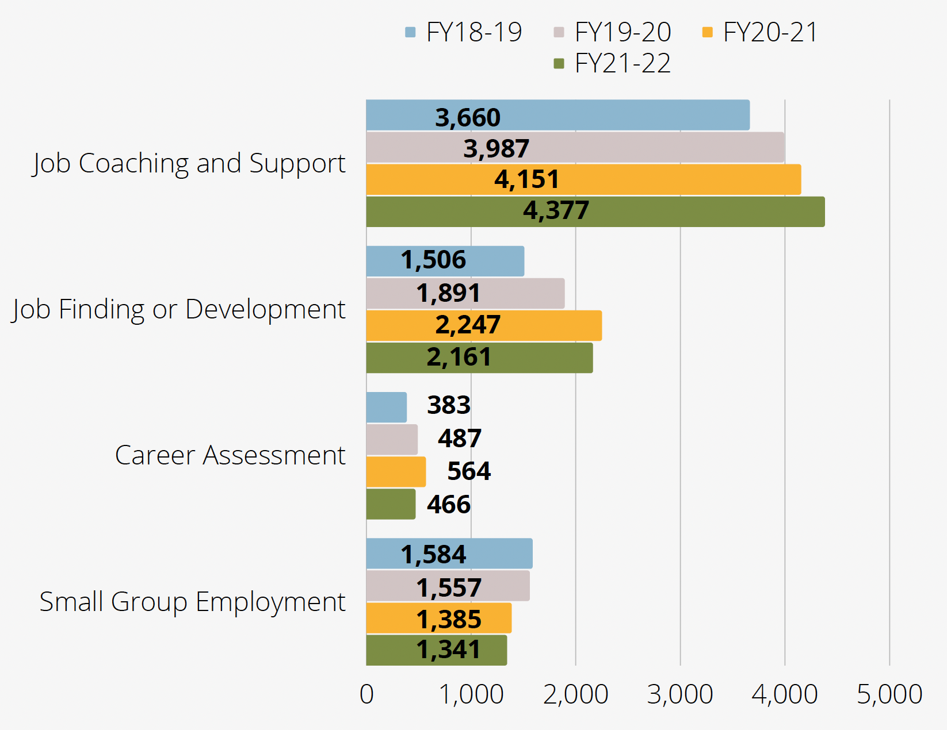
Some people may have more than one service authorized on their individual support plan. For example, a person may be receiving Job Coaching and Support at their place of employment and also receiving Job Finding or Development to search for a second job or new job. That person would be counted twice in the chart above; once in Job Coaching and Support and once in Job Finding or Development.
Data from the bar chart is as follows:
Service | Fiscal Year 2018-2019 | Fiscal Year 2019-2020 | Fiscal Year 2020-2021 | Fiscal Year 2021-2022
Job Coaching and Support | 3,660 people | 3,987 people | 4,151 people | 4,377 people
Job Finding and Development | 1,506 people | 1,891 people | 2,247 people | 2,161 people
Career Assessment | 383 people | 487 people | 564 people | 466 people
Small Group Employment | 1,584 people | 1,557 people | 1,385 people | 1,341 people

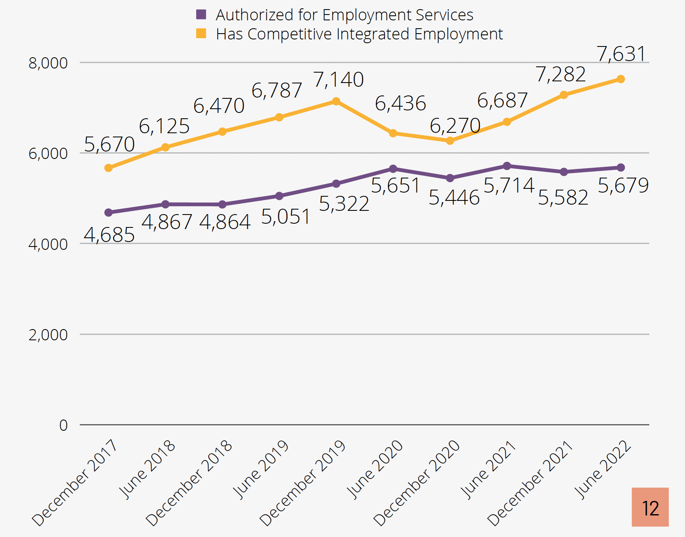

Benefits Counseling
Benefits Counseling services can be an integral part of the development of employment goals for individuals with disabilities and their families. People who depend on continued access to medical care and long term supports and services often fear that earning too much income will result in losing eligibility for publicly funded benefits and services.
Benefits Counseling may be available through the Work Incentives Planning and Assistance Program, often referred to as the WIPA. There are four WIPA programs in Pennsylvania. They are funded by the Social Security Administration.
When Benefits Counseling is not available through a WIPA program, it can be funded by the Consolidated, Community Living, or Person/Family Directed Support waivers or base funding.
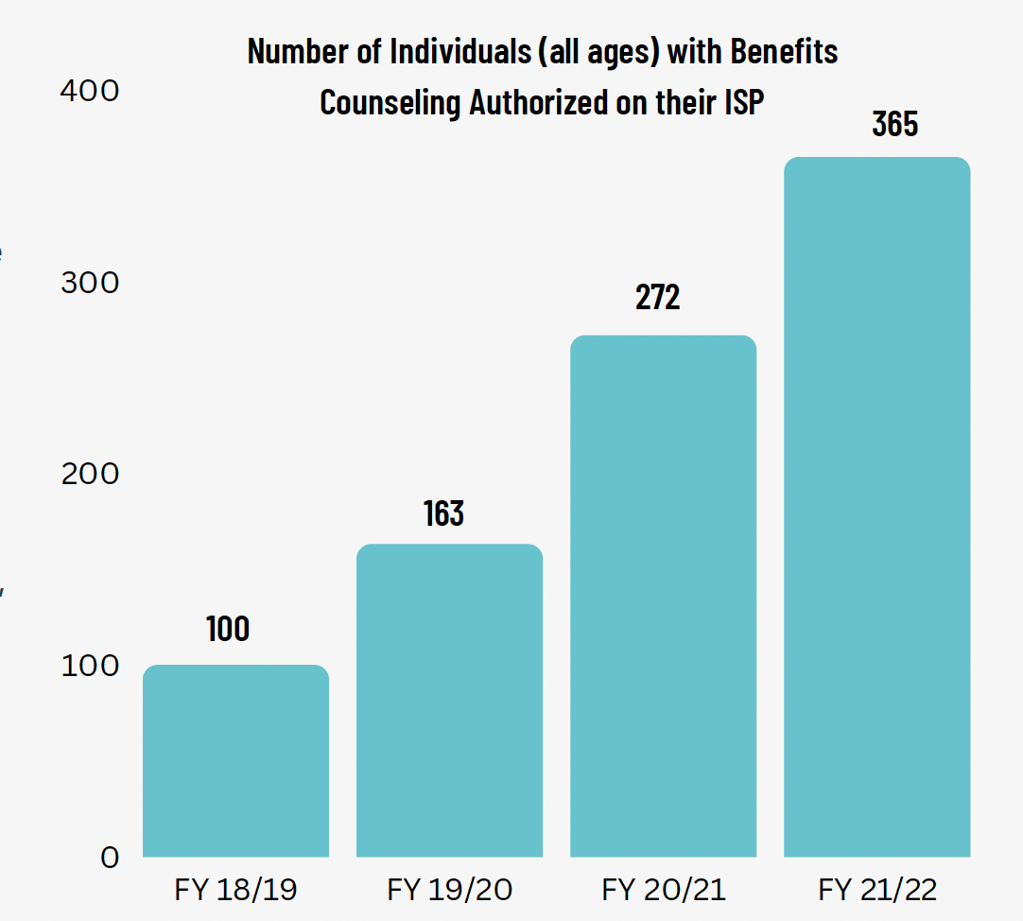
Data from the bar chart is as follows:
Fiscal Year 2018-2019 | Fiscal Year 2019-2020 | Fiscal Year 2020-2021 | Fiscal Year 2021-2022
100 people | 163 people | 272 people | 365 people

In order to deliver Benefits Counseling through an Office of Developmental Programs waiver or base funding, the staff person delivering the service must have either a Community Work Incentives Coordinator certification or a Work Incentive Practitioner credential. In 2022, with the goal of building provider capacity to provide the Benefits Counseling service, the Office of Developmental Programs contracted with Cornell University to deliver the Work Incentives Practitioner credential program to Pennsylvania providers. The Office of Developmental Programs covered the cost of the program for 50 provider staff persons.

SECTION 3: Employment Goals
The Office of Developmental Programs collects data on the number of people enrolled with the Office of Developmental Programs that have an employment goal in their individual support plan. This data is collected from the Employment/Volunteer section of the individual support plan. Supports Coordinators have been instructed to use the following guidance:
Does this consumer have employment goals? Yes or No. Goals could be whether the individual would like to: explore competitive integrated employment, increase or decrease hours of current employment, change jobs, career advancement, etc.
There are many reasons a person may have an employment goal in their individual support plan. For example, a person may be actively pursuing competitive integrated employment, working on building skills that will lead to employment, or know that they want to seek employment at some point, but they are currently focusing on reaching goals that are of higher priority to them.
As of June 30, 2022, there were 13,787 people enrolled with the Office of Developmental Programs that had an employment goal in their individual support plan.
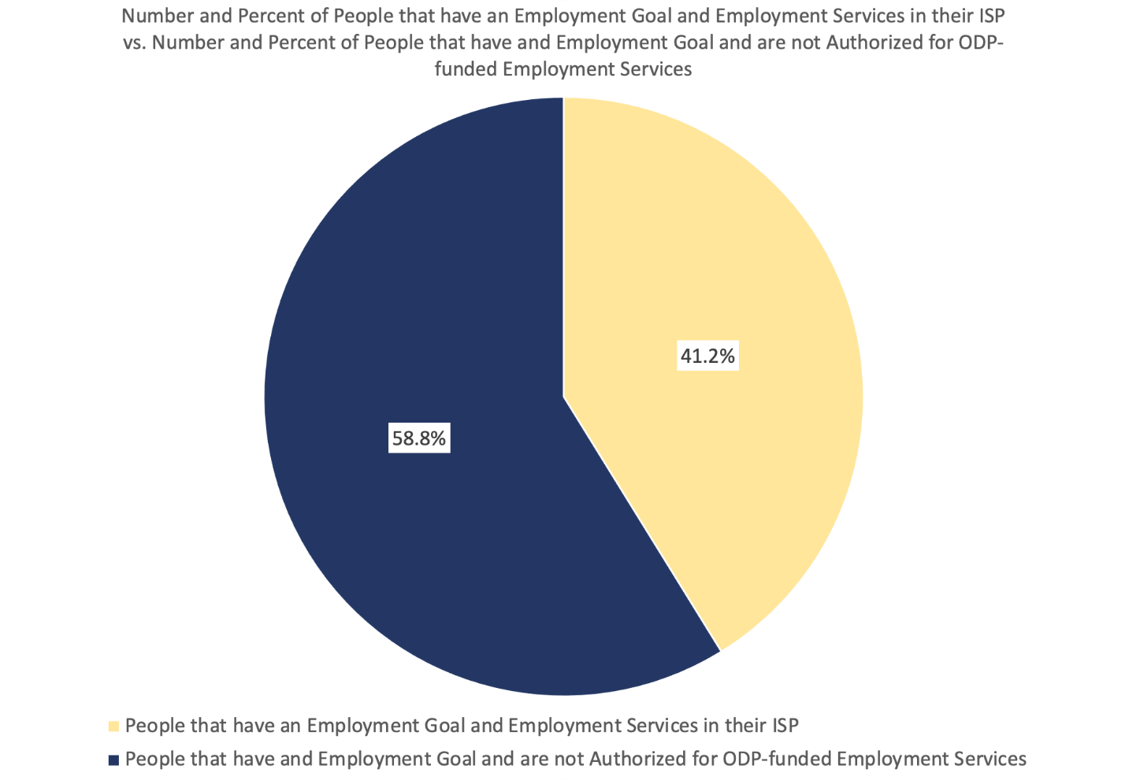
Individuals with an employment goal in their individual support plan that are not authorized for an employment service funded through the Office of Developmental Program may not need employment services to find or keep their job, may be receiving services through a different funding source (for example, the Office of Vocational Rehabilitation), or may be receiving other types of services, such as Community Participation Support, that are helping prepare them for employment in the future.

SECTION 4: Types of Jobs
When individuals have competitive integrated employment, Supports Coordinators record the type of competitive integrated employment by answering the Supports Coordinator Individual Monitoring Employment question, “Job Type – If the individual is working more than one job, select the job with the most hours worked.” Supports Coordinators can select from 23 categories of jobs based on definitions by the Occupational Information Network (O*NET).
The figure below represents the top 3 job type categories for individuals of all ages in competitive integrated employment during at least some point in calendar year 2022.
The top three job categories are food preparation and serving related (33.5%), building and grounds cleaning and maintenance (22.4%), and sales and related (18.9%). These have been the top three types of jobs since the Office of Developmental Programs started collecting this data in 2017. All other types of jobs are included together and represent 25.2% of individuals with competitive integrated employment.
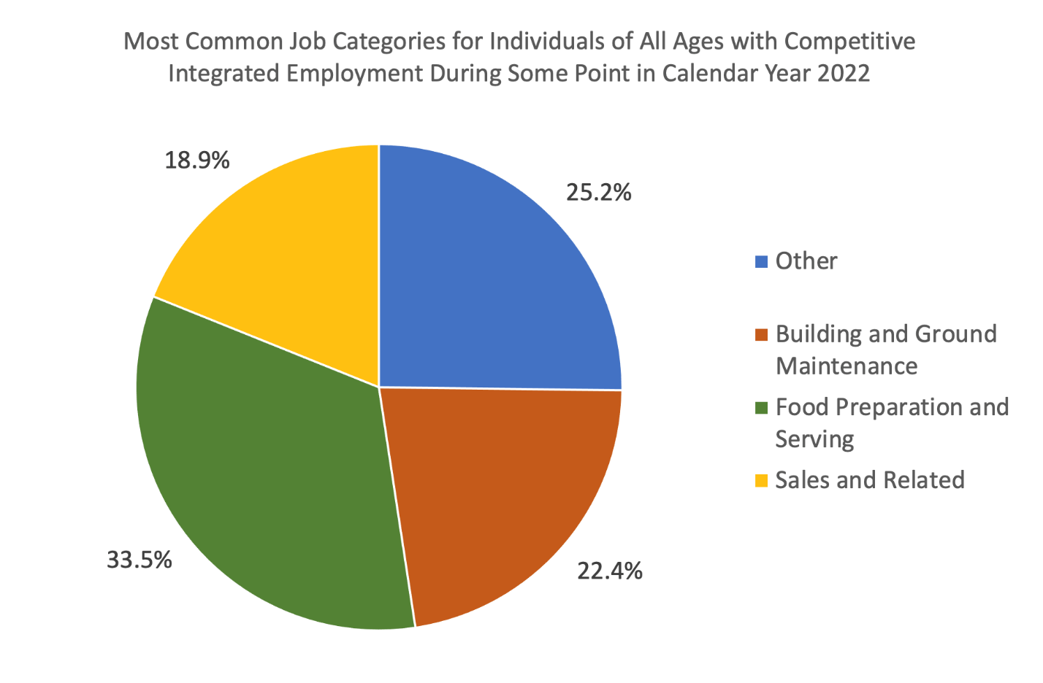
The top three job categories of food preparation and serving related, building and grounds cleaning and maintenance, and sales and related have been the top three types of jobs since the Office of Developmental Programs started collecting this data in 2017.

Collaboration with Workforce Development Professionals
In January of 2021, the Office of Developmental Programs collaborated with internal and external stakeholders to create an Executive Discussion Group. This group included representatives from Workforce Development on a state and regional level and explored how to identify new trends for employment during and after the COVID-19 pandemic. As a result, the Office of Developmental Programs teamed up with the Department of Labor and Industry’s Center for Workforce Information and Analysis. The Center for Workforce Information and Analysis is a primary source of labor market information for Pennsylvania. Their website, PAWorkStats, is a useful tool for watching trends in industry that may help inform a person trying to find a job or trying to decide what type of secondary education or credentials to obtain.
The Office of Developmental Programs, in collaboration with the Office of Long-Term Living, the Office of Mental Health and Substance Abuse Services, and the Pennsylvania Workforce Development Board presented at the Pennsylvania Workforce Development Association’s Annual Conference in 2021 and 2022.
The Office of Developmental Programs participates in the Pennsylvania Workforce Coalition, led by the Pennsylvania Chapter of Association of People Supporting Employment First. The coalition has held numerous workshops for employers that support the employment of people with disabilities.

Section 5: Racial Equity
The Office of Developmental Programs has been taking an in-depth look at the intersection between competitive integrated employment and race in the Office of Developmental Programs’ system. The objective is to evaluate employment goals, services, and outcomes, to determine if disparities exist by race of program participants. Evaluating our own system and outcomes related to competitive integrated employment is the first step to achieving racial equity.
In 2020, the Information Sharing and Advisory Committee adopted recommendation #14 to address racial inequity and systemic racism. A new subcommittee was formed to gather and analyze data, and to develop a framework and strategies to address race-related issues identified, in alignment with Department of Human Services' and Governor’s Office efforts. As a result, a new strategy was developed, under recommendation #3—Increase Employment—to address unemployment through a racial lens.
NEW Everyday Lives Strategy: Disseminate county level employment reports that include comparisons by race to Administrative Entities and local employment coalitions. Engage employment leads and coalitions in discussion about racial disparities and support adoption of local strategies to address the disparities.
The Office of Developmental Programs is preparing to disseminate county level employment reports to the Administrative Entities in the early part of 2023.
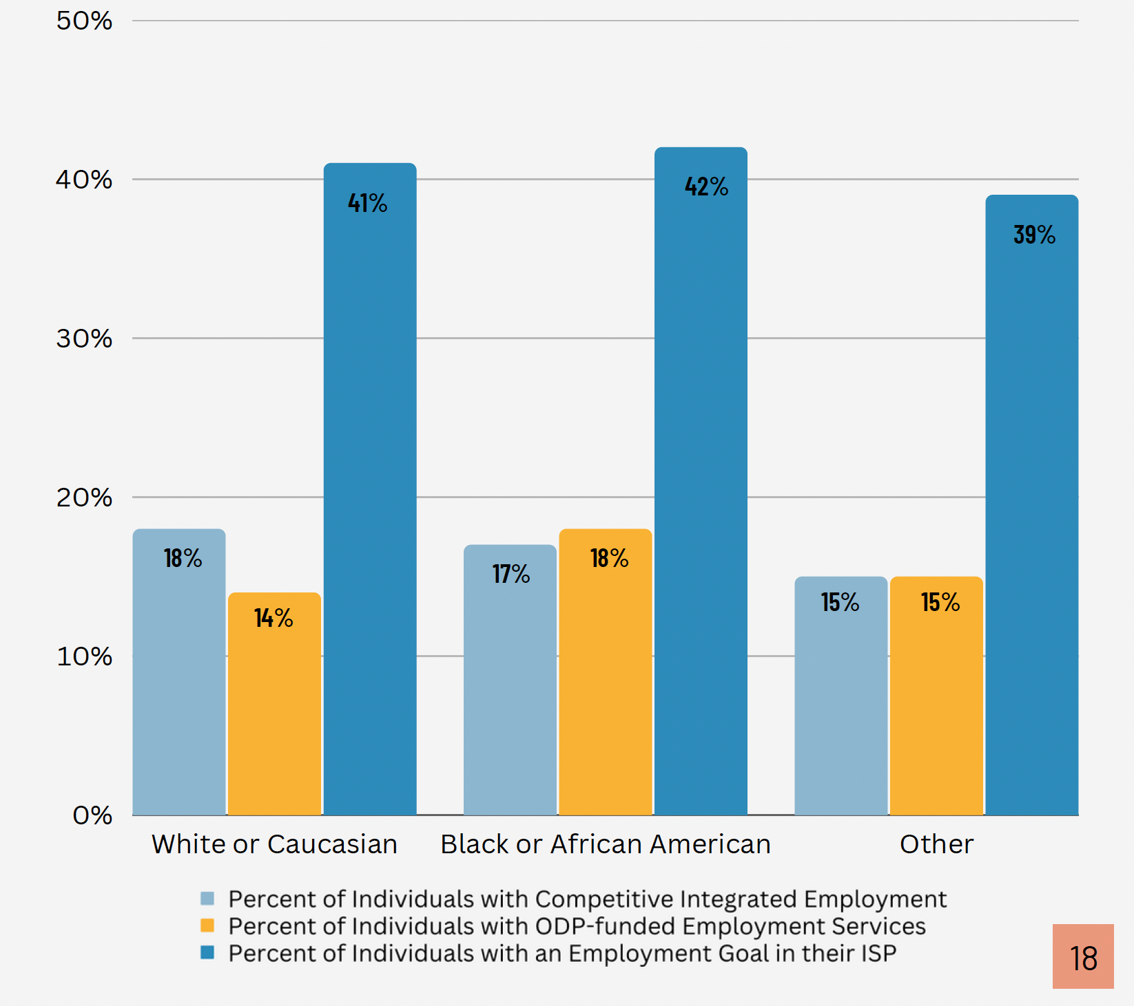
Data from the bar chart is as follows:
Race | Percent of Individuals with Competitive Integrated Employment | Percent of Individuals with Employment Services funded through the Office of Developmental Programs | Percent of Individuals with an Employment Goal in their individual support plan
White or Caucasian | 18% | 14% | 41%
Black or African American | 17% | 18% | 42%
Other | 15% | 15% | 39%

The category of "other" represents people that identify as American Indian, Alaskan Native, Asian, Native Hawaiian, other Pacific Islander, or other race not listed. It also includes people whose race is listed as "unknown" in the Home and Community Services Information System.

Section 6: Prevocational Services
The Community Participation Support service may be used to deliver prevocational services in facility or community locations. Prevocational services may involve activities such as the assessment of a person’s work-related needs, development of basic vocational skills and competencies, development of skills for a specific occupation, teaching understanding of work environment expectations, and more. Prevocational services are expected to lead to competitive integrated employment.

Subminimum Wage Employment for Workers with Disabilities
Under Section 14(c) of the Fair Labor Standards Act, employers can be authorized to pay people with disabilities less than minimum wage for work performed. Some providers enrolled with the Office of Developmental Programs to provide Community Participation Support hold a certificate issued by the United States Department of Labor that allows them to pay subminimum wage. The Department of Labor maintains an online list of all current certificate holders.
The Pennsylvania Employment First Oversight Commission, established by the Employment First Act of 2018, created a measurable goal to annually decrease segregated employment by a minimum of 10% and achieve competitive integrated employment for 30% of working age individuals served by the Office of Developmental Programs. The Commission's full report can be found on Pennsylvania's Employment First website.

Section 511 of the Rehabilitation Act of 1973 Amended by the Workforce Innovation and Opportunity Act of 2014
Under this federal law, people who are age 24 or younger must apply for Office of Vocational Rehabilitation services to improve their access to competitive integrated employment before they are employed at subminimum wage. Under this federal law, people of any age that are employed at subminimum wage must receive career counseling and information from the Office of Vocational Rehabilitation every six months during the first year of subminimum wage employment, and annually thereafter.
The Office of Developmental Programs and the Office of Vocational Rehabilitation have had a Memorandum of Understanding in place since 2017 that allows for the exchange of data that assists in service coordination for people that are receiving services through the Office of Developmental Programs and the Office of Vocational Rehabilitation. Recently, the Office of Developmental Programs and the Office of Vocational Rehabilitation amended this agreement to include an exchange on data for people earning subminimum wage.
There were 4,887 people seen by the Office of Vocational Rehabilitation under Section 511 of the Rehabilitation Act who were active with the Office of Developmental Programs as of June 30, 2022.
This represents 7.8% of all people funded through the Office of Developmental Programs as of June 30, 2022. This includes people of all ages that are enrolled in the Consolidated, Community Living, Person/Family Directed Support, or Adult Autism Waiver, base-funded services, Supports Coordination only, Adult Community Autism Program, private Intermediate Care Facility or State Center.
The Office of Developmental Programs and the Office of Vocational Rehabilitation are working on further analysis of the data for future publications.

Supporting Provider Transformation
Provider transformation is the term used when providers delivering services in segregated settings that pay subminimum wage, such as prevocational facilities, transform their business model to one that provides services that support competitive integrated employment.
One way the Office of Developmental Programs has supported this in 2021 is to offer training and technical assistance to Community Participation Support providers. In July of 2021, twenty-three Community Participation Support providers attended a free three day training on provider transformation. This training was conducted by three nationally-recognized experts in the area of transformation and jointly funded and organized between the Office of Developmental Programs and the Office of Vocational Rehabilitation.
Fifteen providers that attended the training were selected to participate in regional learning collaboratives facilitated by a national expert to assist providers in developing and implementing a plan to take concrete and targeted measures to make the transformation.

Moving Forward
Competitive integrated employment is paramount to living an everyday life. While there has been tremendous progress, there are still many barriers to overcome. The impact of the COVID-19 pandemic on employment for people with disabilities, as well as on their physical and emotional health, is significant. In addition, barriers that existed prior to the pandemic still exist. The Office of Developmental Programs remains committed to the recommendations and provisions of Everyday Lives and the Employment First Act. With valuable insight from all stakeholders, the Office of Developmental Programs is committed to supporting individuals with intellectual disabilities or autism to achieve their employment aspirations.
A quote from the Everyday Lives in Action; Values Statement
“I want to work and/or have other ways to contribute to my community. My family, supporters, and community support me to find and keep a real job that I like with good wages and benefits or start and run my own business, and/or volunteer the way I want in my community.”

