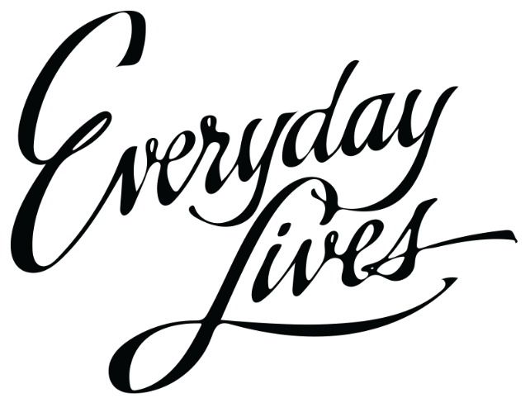

Call For Proposals:

2024 Everyday Lives Conference

Health, Wellness & Safety Poster Symposium

ABOUT
The 2024 Everyday Lives Conference Steering Committee is inviting all Office of Developmental Programs (ODP) stakeholders to submit poster proposals for the conference poster symposium. The topic of the poster symposium will focus on Everyday Lives Recommendation Number Five - Promote Health Wellness, and Safety. Individuals with an intellectual or developmental disability/autism (IDD/A), families, caregivers, direct support professionals, providers, clinicians, and other professionals are encouraged to submit proposals. Have you developed an innovative model to encourage healthy lifestyle habits when supporting individuals with IDD/A? Are you a self-advocate who has developed a routine for healthy eating, exercise, and/or mental well-being? Then we want to hear from you!
WHAT SHOULD YOUR PROPOSAL INCLUDE?
When submitting through the online form, you'll have the opportunity a brief text description of your proposal. Please include a general synopsis (abstract) of your proposed poster topic. Topics should be relevant to Everyday Lives Recommendation Number Five - Promote Health, Wellness, and Safety:
Promote physical and mental health, wellness, and personal safety for every individual and their family. Promoting physical and mental health means providing information about health and wellness, emotional support, and encouragement. Tools that help every individual adopt a healthy lifestyle — including good nutrition, healthy diets, physical activity, and strategies to reduce and manage stress and protect oneself from all types of abuse and exploitation — must be provided.

Your proposal should center around your innovative practices of promoting and encouraging at least one of the following in your everyday life, or the everyday lives of those you support:
- Physical activity
- Mental health and wellbeing
- Safety
- Nutrition
- Healthy diets
- Stress management
- Emotional support
- Abuse and exploitation prevention

IMPORTANT DATES
The selection committee will pick seven to ten posters to be featured at the symposium. Submissions are due by September 22, 2023 and you will be notified of your selection by October 13, 2023. Selected submissions will be granted free admission for two (2) to all three days of the 2024 Everyday Lives Conference, January 9 through 11, 2024. The Everyday Lives Conference will be held in-person only (no virtual or hybrid component).
The poster symposium will take place during the 2024 Everyday Lives Conference on January 10, 2024 at the Hershey Lodge in Hershey Pennsylvania.

POSTER FORMAT
If you receive confirmation that your proposal has been selected, you will be responsible for developing your own poster. Reference materials regarding set-up, display, and breakdown times will be provided at a later date. Posters should be flat foam core, landscape oriented, and no larger than 56 inches by 42 inches. Easels will be provided.

Click Here to Submit Your Poster Proposal!

Any questions regarding the poster submission process can be sent to: RA-PWODP_OUTREACH@pa.gov

