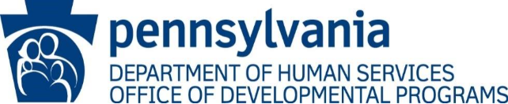

Email Subject Line: QA&I C3Y2 Full Review Directed Corrective Action/Plan to Prevent Recurrence

Good morning/afternoon,

As detailed in ODP Announcement 25-061 the Office of Developmental Programs (ODP) Quality Assessment & Improvement (QA&I) Cycle 3, Year 2 Review Process started on July 1, 2026.

One part of this process is the requirement that Administrative Entities, Supports Coordination Organizations, and Providers must complete a Full Review based on MPI number, annually by December 31st.
Your agency failed, which based on MPI number, to participate in a Full Review by this date. Therefore, a Directed Corrective Action Plan (DCAP) is being issued which is attached.

Your agency is required to complete and submit the QA&I Full Review Directed Corrective Action Plan (DCAP) including the requested documentation by [insert date – 15 calendar days from when the DCAP is sent]. Failure to comply will result in follow-up action.

If you have any questions, please contact me.

Sincerely,

QA&I Lead
Cc: ODP QA&I Regional Coordinator

